***1. INTRODUCTION****:*

*1.1 Overview:*

*The electricity consumption represents the amount of electrical energy that has been consumed over a specific time in units of Wh, electricity demand represents that rate at which electrical energy is consumed for a needed output rating, in units of W. Electricity is the energy that makes a work through the ordered flow of electrons.*

*1.2 Purpose:*

*People use electricity for lighting ,heating, cooling ,and refrigeration and for operating appliances, computers, electronics, machinery, and public transportation systems. Energy consumption refers all the energy used to perform an action, manufacture something or simply inhabit a building.*

***2. PROBLEM DEFINITION AND DESIGN THINKING:*** *2.1 Empathy Map:*

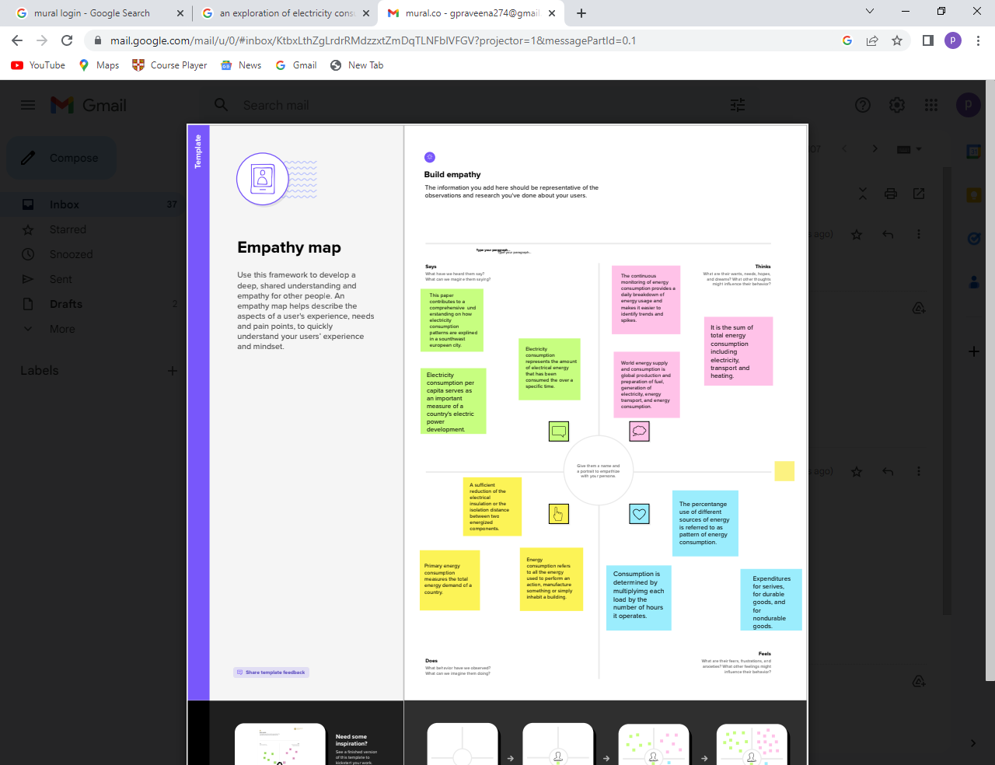

*2.2 Ideation and Brainstorm Map:*

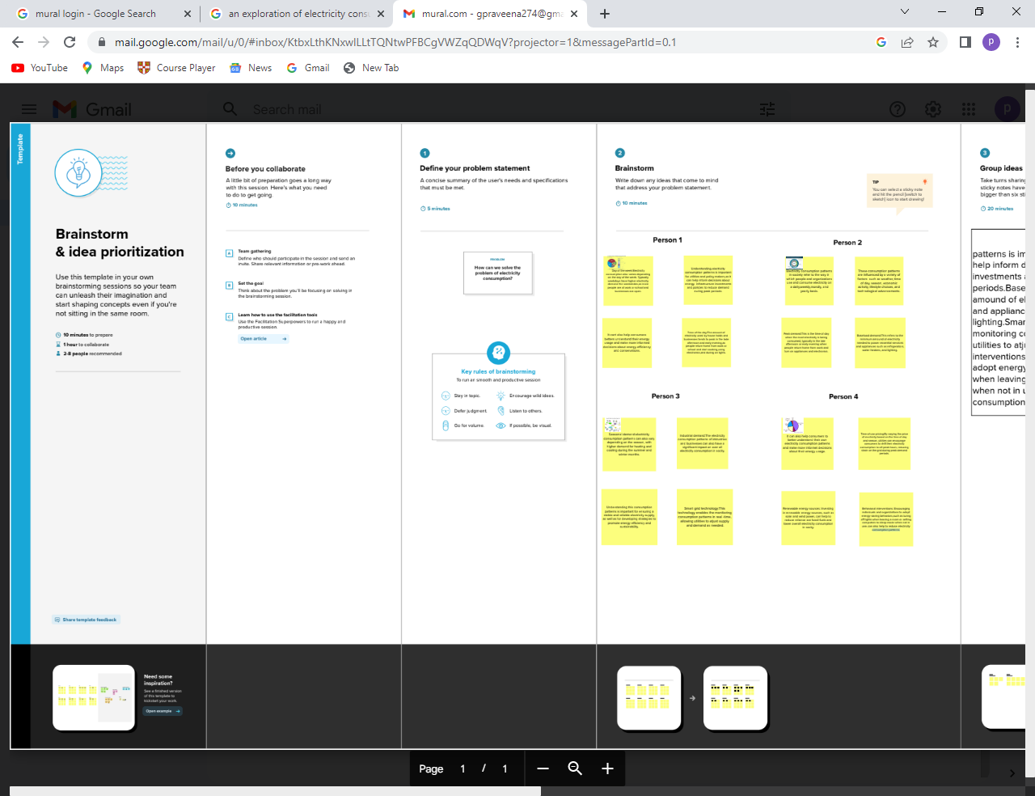

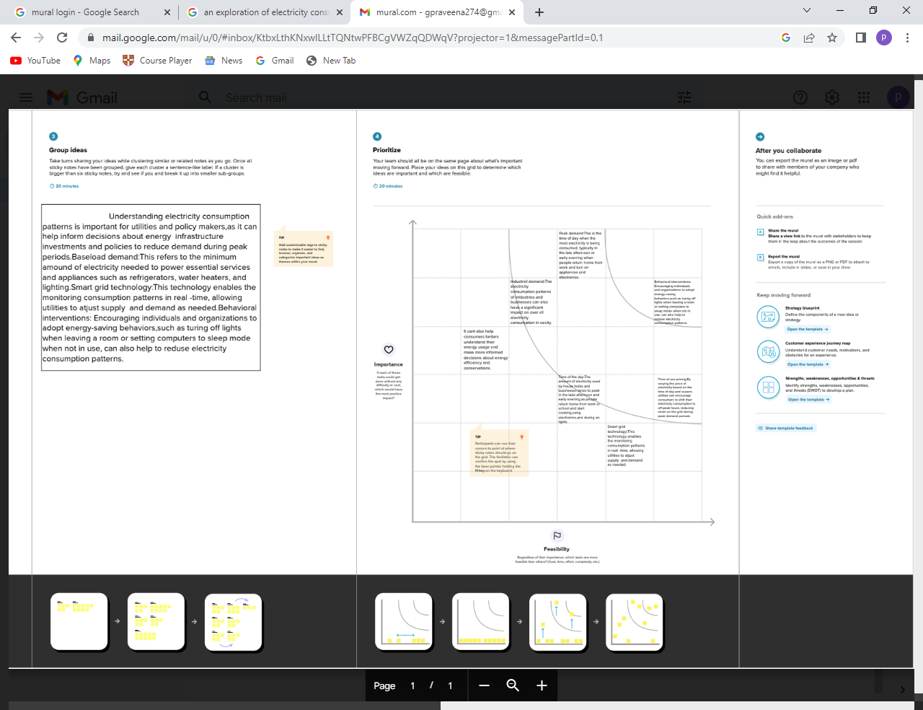

***3. RESULT****:*

**

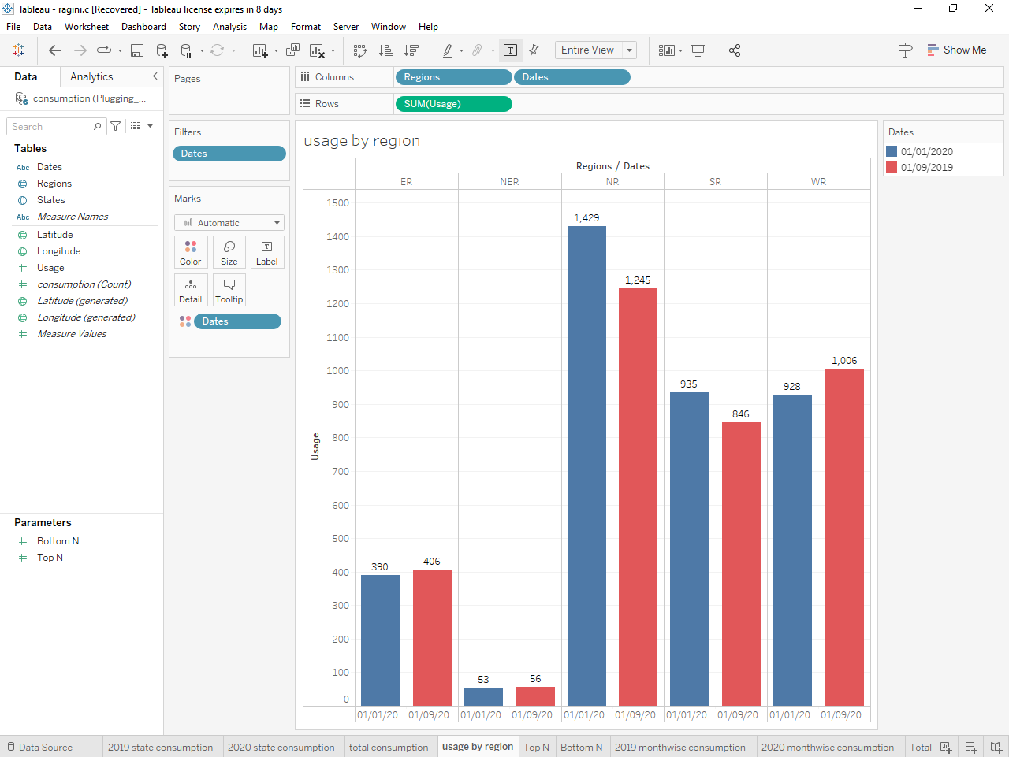

**

**

***4. ADVANTAGES AND DISADVANTAGES:***

*ADVANTAGES:*

* *It is a clean, safe, cheap and convenient source of energy.*
* *Lower maintenance cost.*
* *More efficient.*
* *No tailpipe emission.*
* *We all know that it can be set up in many sizes.*
* *It does not require as many employes.*
* *Reduces greenhouse emission.*

*DISADVANTAGES:*

* *More expensive than gasoline.*
* *Loss of fish species.*
* *Sometimes messes up wildlife.*
* *Dependent on precipitation.*
* *More power plants and more pollution.*
* *Damming can cause loss of land suitable for agriculture as well a recreation.*
* *Cost for construction.*
* *Change in river or stream quality.*

***5. APPLICATIONS:***

1. *In some manufacturing processes, electricity is used to increase the temperature of components in order to achieve desires product shape. While some industrial facilities build their own power generation plants, other rely on supply from utilities.*
2. *Electricity all types of energy and uses. The natural gas space and water heating, clothes drying, cooking. The heating oil space and water heating clothes drying.*

***6. CONCLUSION:***

*Current through a given area of a conductor is the net charge that passes per unit time through the conductor. To keep up a gradual current, we must have a circuit within which on electrical phenomenon occurs from lower to higher mechanical energy.*

***7. FUTURE SCOPE:***

*In the stated policies scenario, global electricity demand grows at 2.1% per year to 2040, twice the rate of primary energy demand. This raises electricity share in total final energy consumption form 19% in 2018 to 24% in 2040. Electricity demand growth is set to be particularly strong in developing economies.*

***8. APPENDIX****:*

*1. https://drive.google.com/file/d/1pVHAOm5Z_5mJlEeVTH232l_dXE38W0eB/view?usharing*

*2 .https://drive.google.com/file/d/1MEthsJ89teEYR6k688W-7i5Bk0dEBIo2/view?usp=sharing*

*3 .https://drive.google.com/file/d/1utqB_EInIi2AFb4tT7Nr2RSsznRVe5Ty/view?usp=sharing*

*4.* *https://drive.google.com/file/d/1qxELSCEc_yoM9wDOJXj9hIHxgoG25gO/view?usp=sharing*

*5. https://drive.google.com/file/d/1hvXhX09fEFC7gqXSGdDY-yS7ghbZgp9S/view?usp=sharing*